## **Calculate the LOC of initial version**

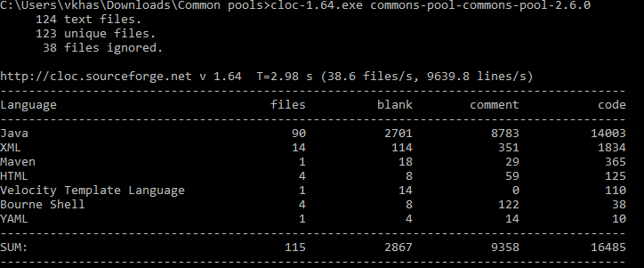

## **Add data in excel sheet**

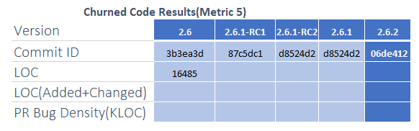

## **Find LOC for next commit (not version)**

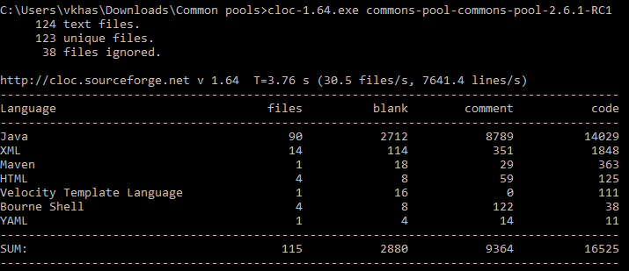

## **Add data in excel sheet**

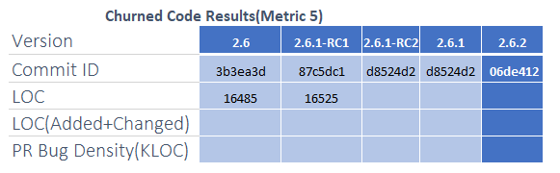

## **Find difference between two commits using command cloc-1.64.exe -diff commit1 commit2**

C:\Users\vkhas\Downloads\Common pools>cloc-1.64.exe -diff commons-pool-commons-pool-2.6.0 commons-pool-commons-pool-2.6.1-RC1

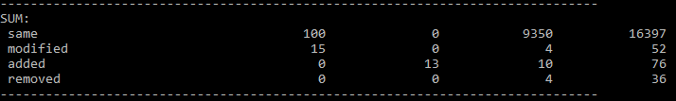

**Churned LOC = 52 + 76 = 128**

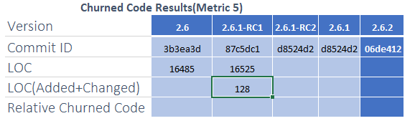

## **Find LOC for next commit (2.6.1-RC2)**

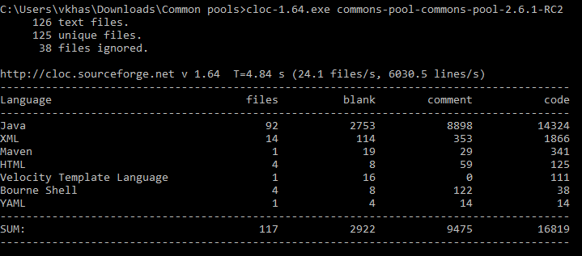

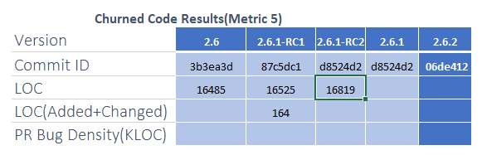

C:\Users\vkhas\Downloads\Common pools>cloc-1.64.exe -diff commons-pool-commons-pool-2.6.1-RC1 commons-pool-commons-pool-2.6.1-RC2

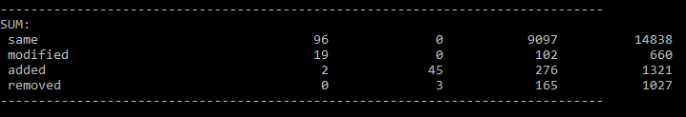

**Churned LOC = 660 + 1321 = 1981**

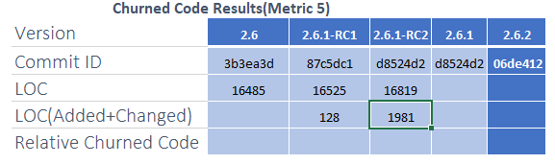

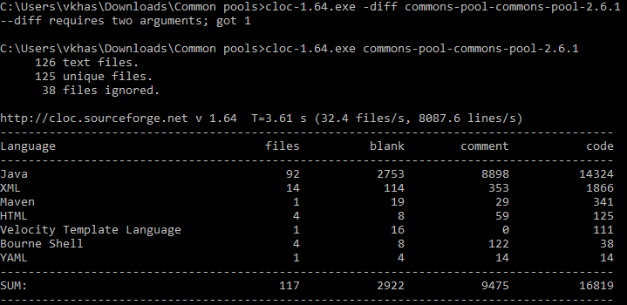

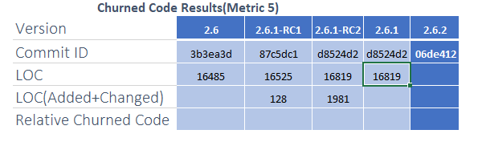

C:\Users\vkhas\Downloads\Common pools>cloc-1.64.exe -diff commons-pool-commons-pool-2.6.1-RC2 commons-pool-commons-pool-2.6.1

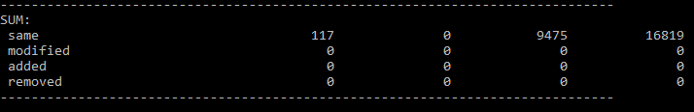

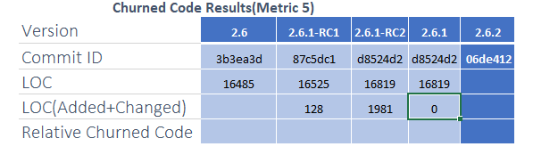

**Relative Churned score between versions 2.6 and 2.6.1   
Relative Churned LOC = Churned LOC / LOC of Final Version**

# Churned LOC = 128+1981 = 2109/16819 **≈** **0.12539**

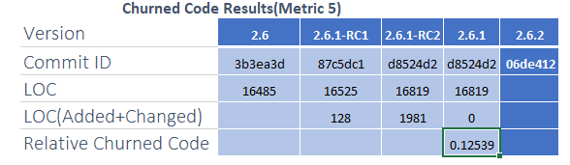

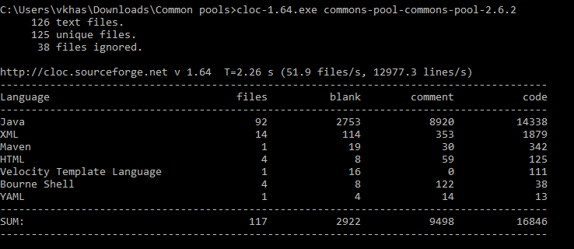

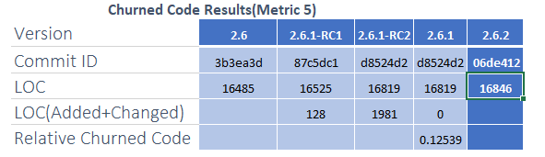

C:\Users\vkhas\Downloads\Common pools>cloc-1.64.exe -diff commons-pool-commons-pool-2.6.1 commons-pool-commons-pool-2.6.2

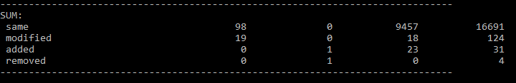

**Churned LOC = 124 + 31 = 155**

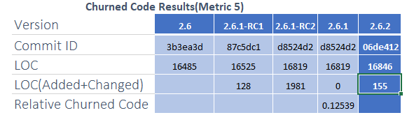

**Relative Churned score between versions 2.6.1 and 2.6.2   
Formula - Relative Churned LOC = Churned LOC / Total LOC**

# Churned LOC = 155/16846 = **0.009201**

